Coursera Capstone Project

In accordance with ***IBM Data Science Professional Certificate***, Course:9, ***Applied Data Science Capstone***

Opening up of a new Mexican Restaurant in the city of ***Bangalore, India.***

by: T. Neethi Thevan

-July 2019-

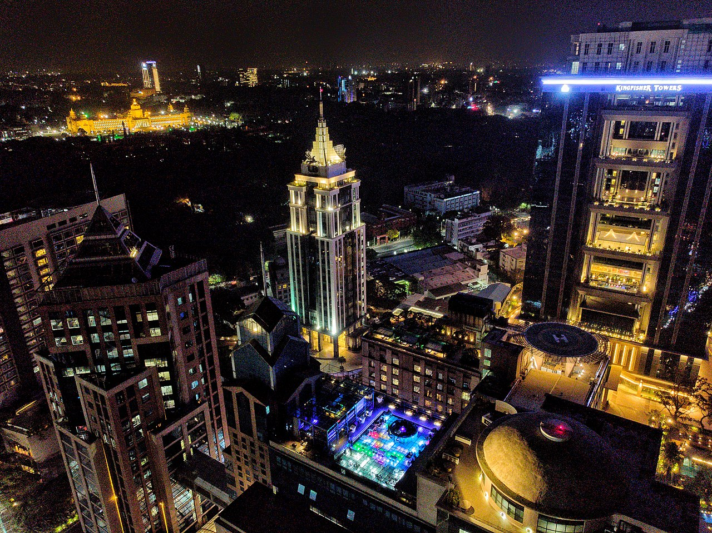Aerial view of UB City at night. **Bangalore, India**

**About the city,**

Bangalore, [officially](https://en.wikipedia.org/wiki/List_of_renamed_Indian_cities_and_states) known as Bengaluru, is the [capital](https://en.wikipedia.org/wiki/Capital_city) of the [Indian state](https://en.wikipedia.org/wiki/Indian_state) of [Karnataka](https://en.wikipedia.org/wiki/Karnataka). It has a population of about 10 million and a [metropolitan](https://en.wikipedia.org/wiki/Metropolitan_area) population of about 8.52 million, making it the [third most populous city](https://en.wikipedia.org/wiki/List_of_most_populous_cities_in_India) and [fifth most populous urban agglomeration](https://en.wikipedia.org/wiki/List_of_million-plus_urban_agglomerations_in_India) in India. Located in [southern India](https://en.wikipedia.org/wiki/Southern_India) on the [Deccan Plateau](https://en.wikipedia.org/wiki/Deccan_Plateau), at a height of over 900 m (3,000 ft) above sea level, Bangalore is known for its pleasant climate throughout the year. Its elevation is the highest among the major cities of India. Bangalore is widely regarded as the **"**[**Silicon Valley**](https://en.wikipedia.org/wiki/Silicon_Valley)**of India"** (or "IT capital of India") because of its role as the nation's leading [information technology](https://en.wikipedia.org/wiki/Information_technology) (IT)exporter. Indian technological organisations such as [ISRO](https://en.wikipedia.org/wiki/Indian_Space_Research_Organisation), [Infosys](https://en.wikipedia.org/wiki/Infosys), [Wipro](https://en.wikipedia.org/wiki/Wipro) and [HAL](https://en.wikipedia.org/wiki/Hindustan_Aeronautics_Limited) are headquartered in the city. A demographically diverse city, Bangalore is the second fastest-growing major metropolis in India. Recent estimates of the [metro economy](https://en.wikipedia.org/wiki/Gross_metropolitan_product) of its urban area have ranked Bangalore either the [fourth or fifth-most productive metro area](https://en.wikipedia.org/wiki/List_of_cities_by_GDP) of India. It is home to many educational and research institutions in India, such as [Indian Institute of Science](https://en.wikipedia.org/wiki/Indian_Institute_of_Science) (IISc), [Indian Institute of Management (Bangalore)](https://en.wikipedia.org/wiki/Indian_Institute_of_Management_Bangalore) (IIMB), [International Institute of Information Technology, Bangalore](https://en.wikipedia.org/wiki/International_Institute_of_Information_Technology,_Bangalore) (IIITB), [National Institute of Fashion Technology](https://en.wikipedia.org/wiki/National_Institute_of_Fashion_Technology), Bangalore, [National Institute of Design, Bangalore](https://en.wikipedia.org/wiki/National_Institute_of_Design,_Bangalore) (NID R&D Campus), [National Law School of India University](https://en.wikipedia.org/wiki/National_Law_School_of_India_University) (NLSIU) and [National Institute of Mental Health and Neurosciences](https://en.wikipedia.org/wiki/National_Institute_of_Mental_Health_and_Neurosciences) (NIMHANS). Numerous state-owned [aerospace](https://en.wikipedia.org/wiki/Aerospace) and [defence organisations](https://en.wikipedia.org/wiki/Defence_industry), such as [Bharat Electronics](https://en.wikipedia.org/wiki/Bharat_Electronics), [Hindustan Aeronautics](https://en.wikipedia.org/wiki/Hindustan_Aeronautics_Limited) and [National Aerospace Laboratories](https://en.wikipedia.org/wiki/National_Aerospace_Laboratories) are located in the city. The city also houses the [Kannada film industry](https://en.wikipedia.org/wiki/Kannada_film_industry).

**Business Problem Statement,**

My client, a multinational Mexican Restaurant chain, ***Tacolicous*** is planning to open up a restaurant in the city of Bangalore. They prefer that location of the restaurant should be within the city limits as well as should be as far as it can be from any other Mexican restaurant. This is to attract more customers and to reduce the competency.

**Target Audience of this project,**

The analysis can be very help to particular person or an organisation that are keen on opening a restaurant in the city of Bangalore. They can be befitted by the knowledge of different hotels in a particular locality and which can be used to make important decision on the setting up of the restaurant.

**Data**

* **Data Requirement**

1. The name of all neighbourhoods in the city of Bangalore.
2. The latitude and longitude of all the neighbourhoods.
3. Information about the type of restaurant/hotels in a particular locality.

* **Data collection**

1. For administrative purposes, the city of [Bangalore](https://en.wikipedia.org/wiki/Bangalore) is divided into nine zones, which are further subdivided into a total of 198 [wards](https://en.wikipedia.org/wiki/Ward_(electoral_subdivision)) administered by the [Bruhat Bengaluru Mahanagara Palike](https://en.wikipedia.org/wiki/Bruhat_Bengaluru_Mahanagara_Palike) (BBMP).The names of localities of Bangalore can be found in terms of city corporation wards. This data is available at the link given below,

url: <https://en.wikipedia.org/wiki/List_of_wards_in_Bangalore>

1. For finding the latitude and longitude of these neighbourhood was be found by scrapping the google web search results.
2. The Foursquare API allows application developers to interact with the Foursquare platform. The API itself is a RESTful set of addresses to which you can send requests. The API accepts coordinates of a place as request and returns the details of top 100 popular venues surrounding the place.

The results include a large variety of venues including parks, ATM, shopping malls etc. We can filter out the names and type of restaurants from them easily.

.

* **Data Analysis**

After the procurement of the data EDA and data wrangling operations are done. Basically, all the data is converted in to a data frame and ***K-means clustering*** ***algorithm*** is used to see how the different neighbourhood clusters. ***Folium map*** is used to visualize the locations of all neighbourhood in Bangalore city. ***wordcloud*** visualization is used to examine the properties of different clusters.